

**CIS 11042 – Practical for Essential of ICT and PC Applications**

Information and communication Technology

Faculty of Technology

South Eastern University of Sri Lanka

Registration Number: SEU/IS/22/ICT/075

Academic year: 22/23

Date: 09.03.2023

**Exercise 01**

1. 1. Open word -> click on “Blank Document” -> writing two paragraph about “Essential of ICT in real life”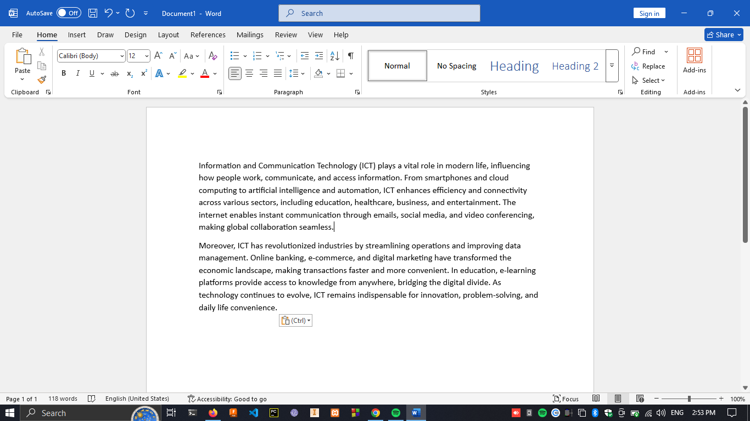

2. in Ribbon tab select “Breaks” under “Layout” and click on “Page”.

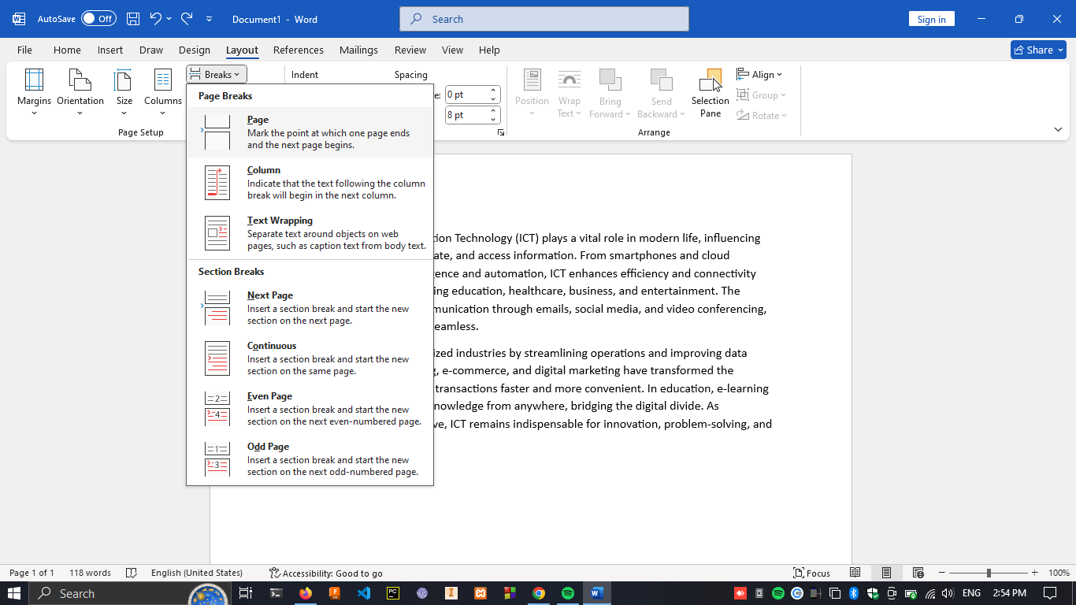

3. under the “Columns” and click on Two while selecting all text in 2nd paragraph

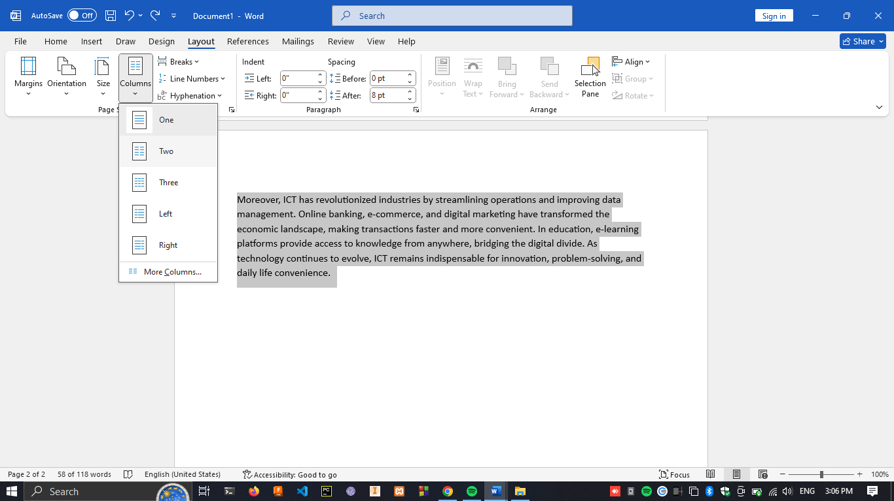

4. under “Breaks” click on “Next Page” while on next new page

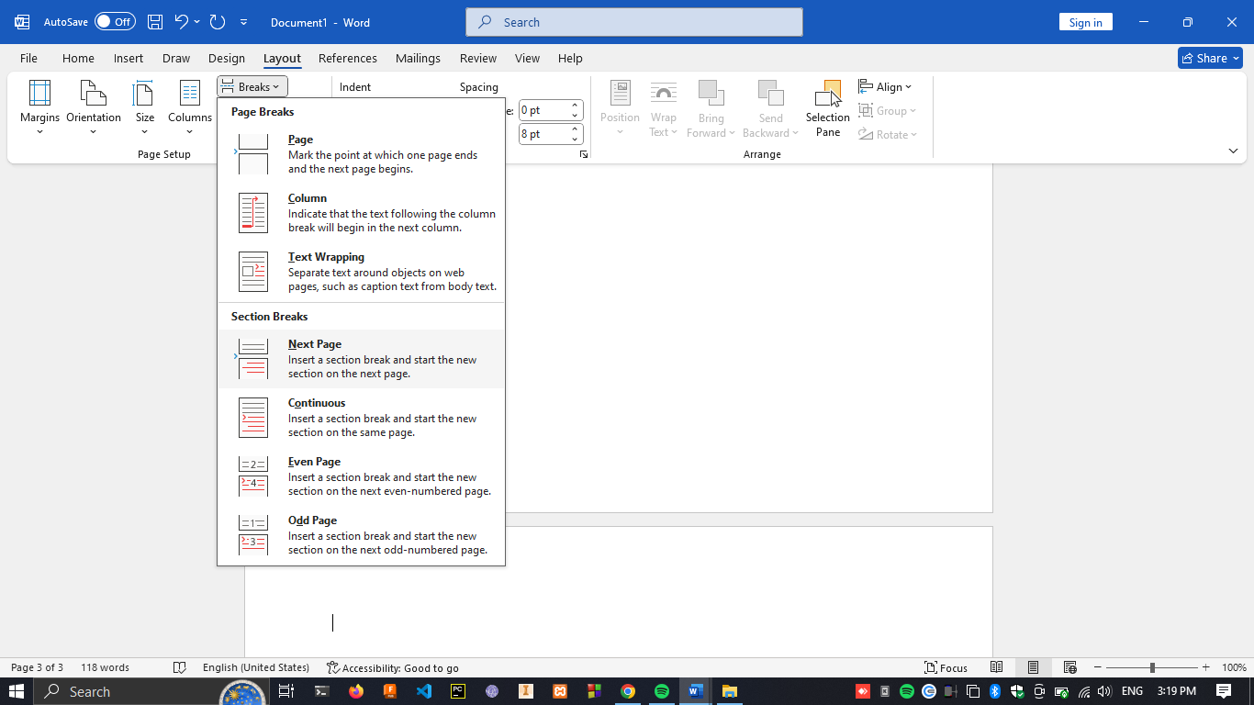

1. 1. Double click on the Header section to enable Header & Footer Editing window and add Name and Lab Sheet 04

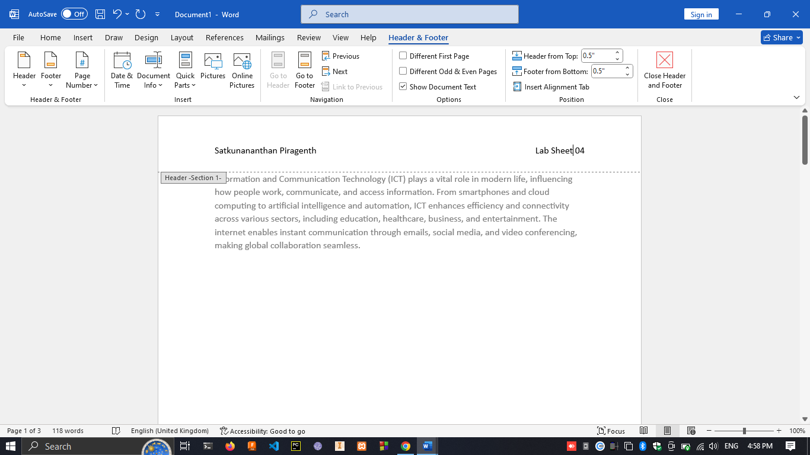

2. click on Footer section -> click on “Date & Time” -> click current date on window ->click ok , Do the same thing for Time.

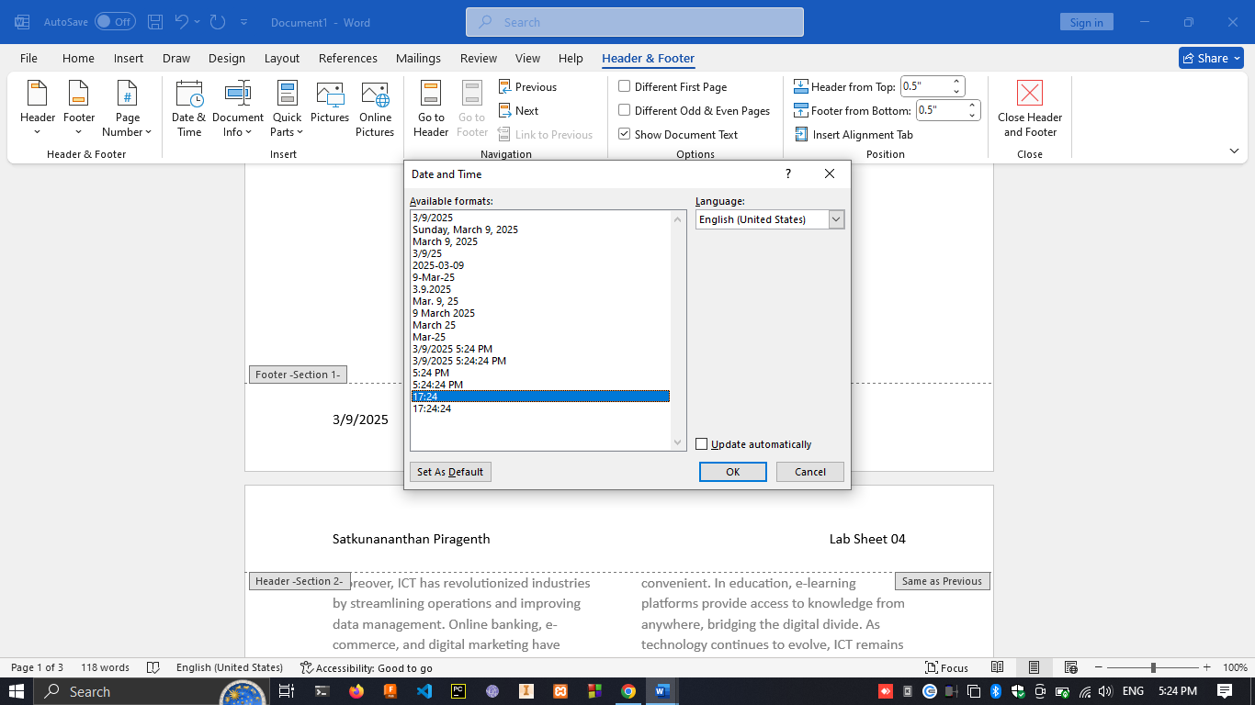

3. under “page Number” clicking on page number system as wanted -> click on “Different First Page” -> click on “Page Number” -> click on “Format page number” -> add 1 at starts at

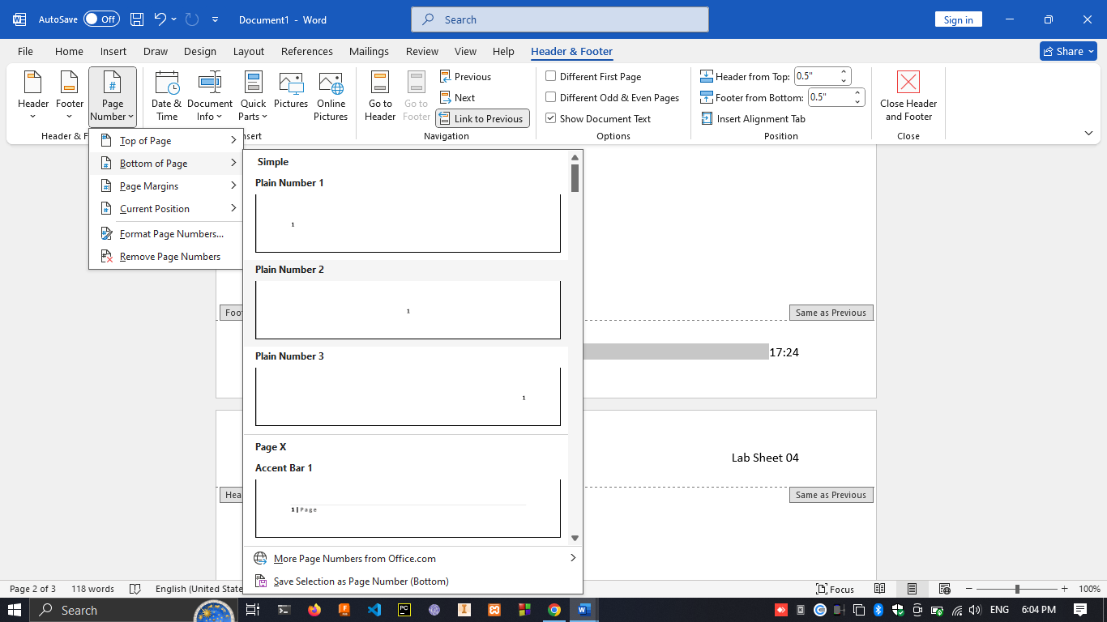

**Exercise 02**

1. 1. In Paragraph -> “layout” -> “insert image” -> under wrap text -> select “Tight”.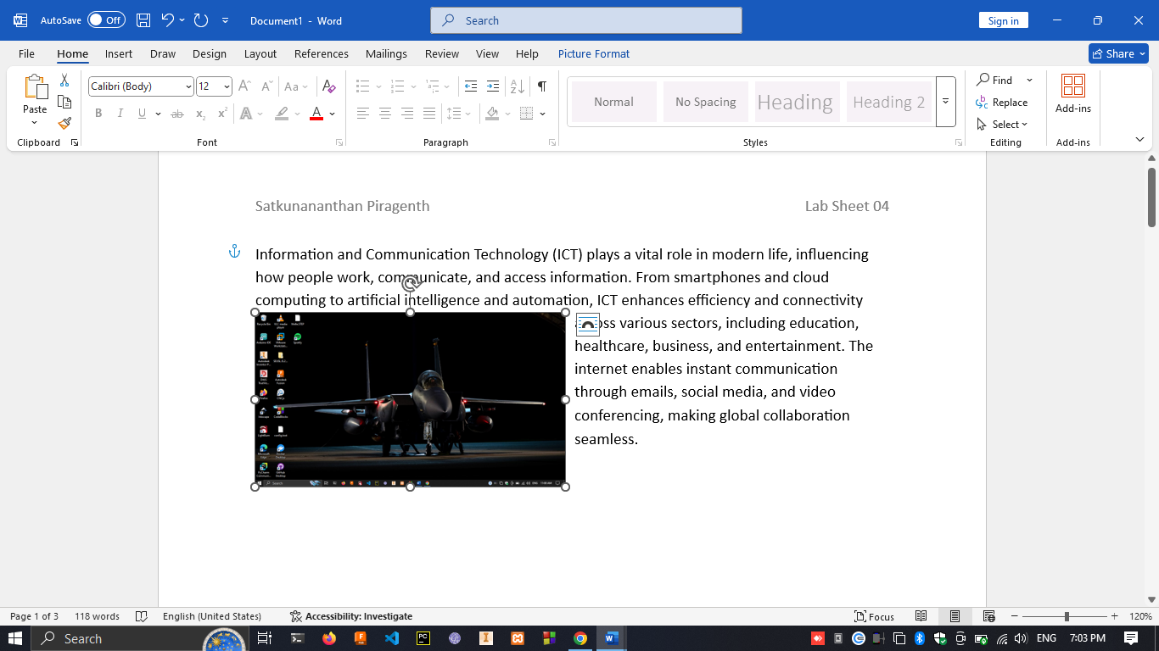

2. drag and drop image to the right side of the page

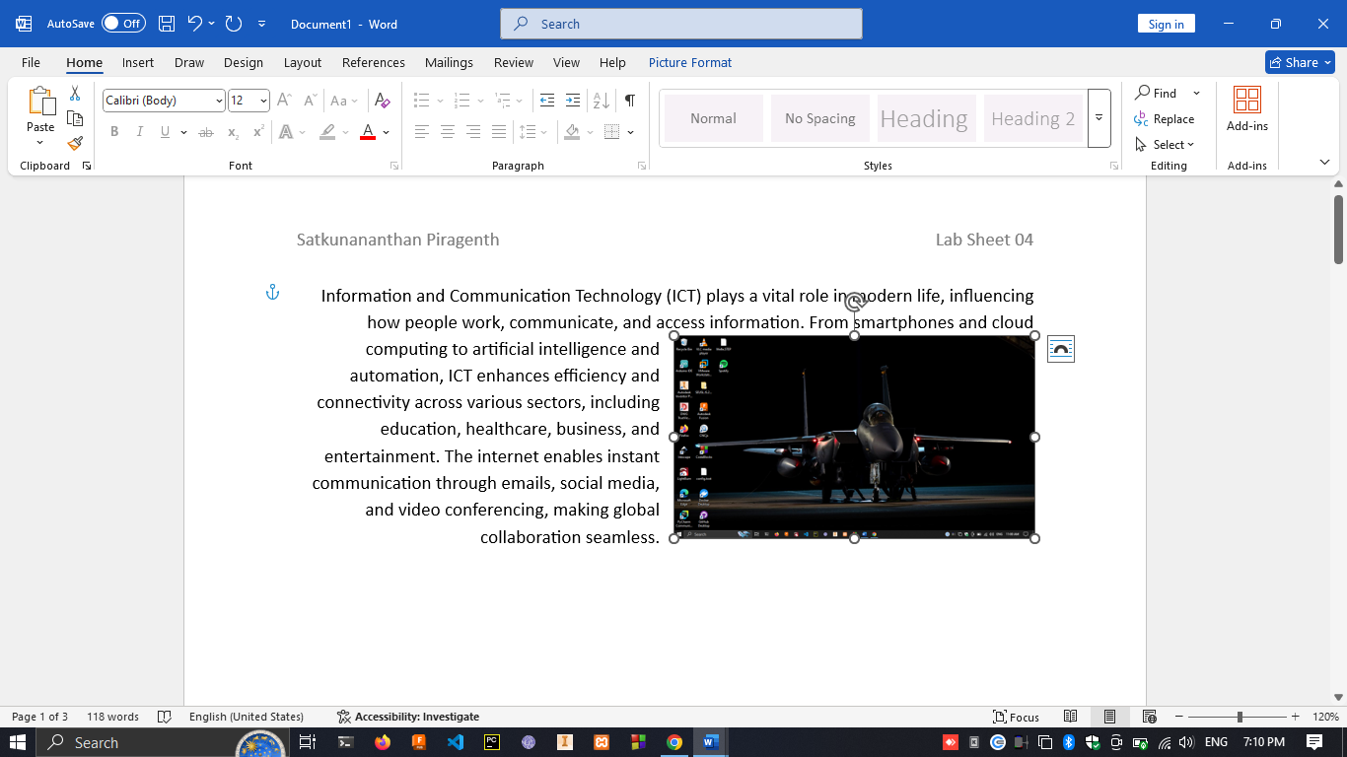

3. in ribbon tab click on “insert” -> “pictures” -> “online table”

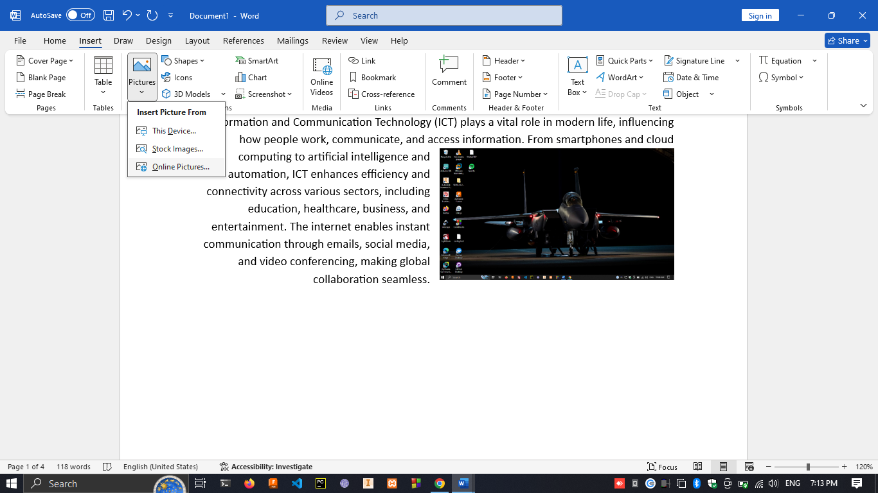

4. click on “Chart” under insert tab -> click on ok -> click on title and rename to “Sales charts”

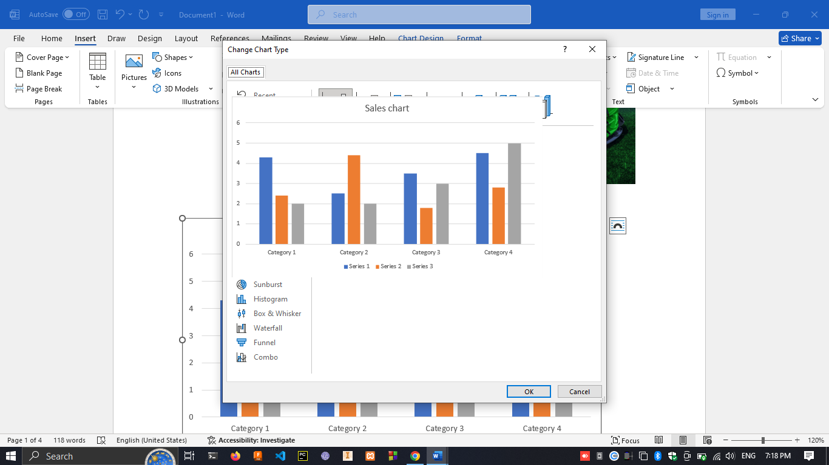

5. click on one column and click on “change colors”

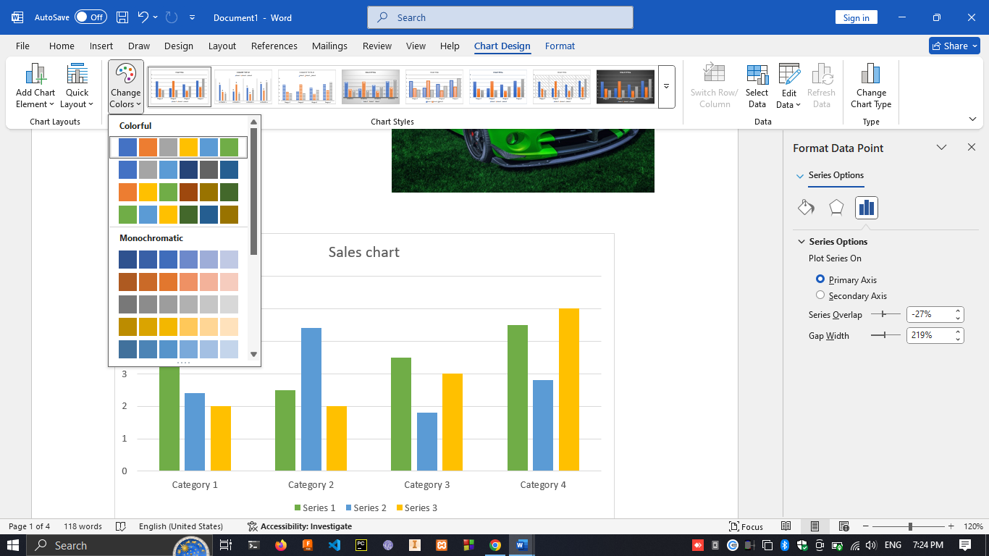

**Exercise 03**

1. 1. Under insert select any cover page under “Cover page”

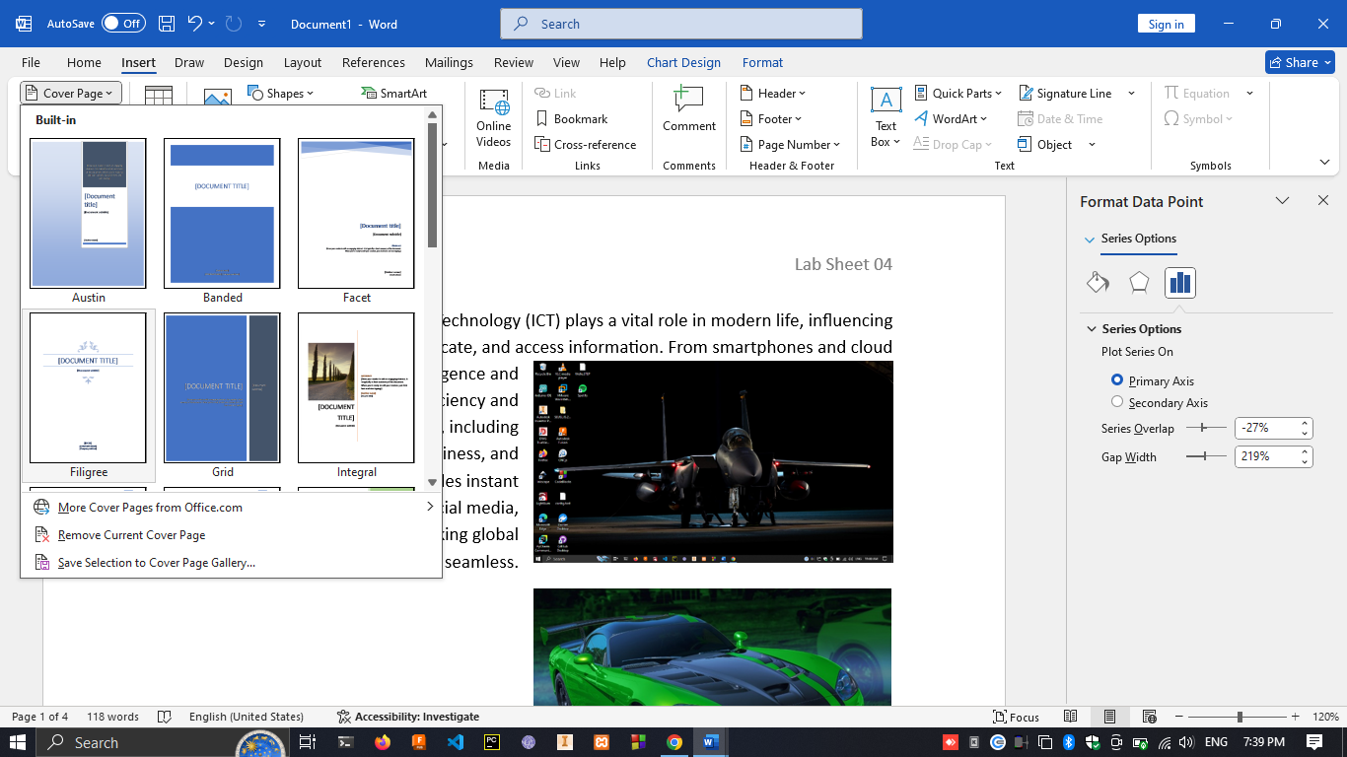

2. under column under “Layout” -> select any setting.

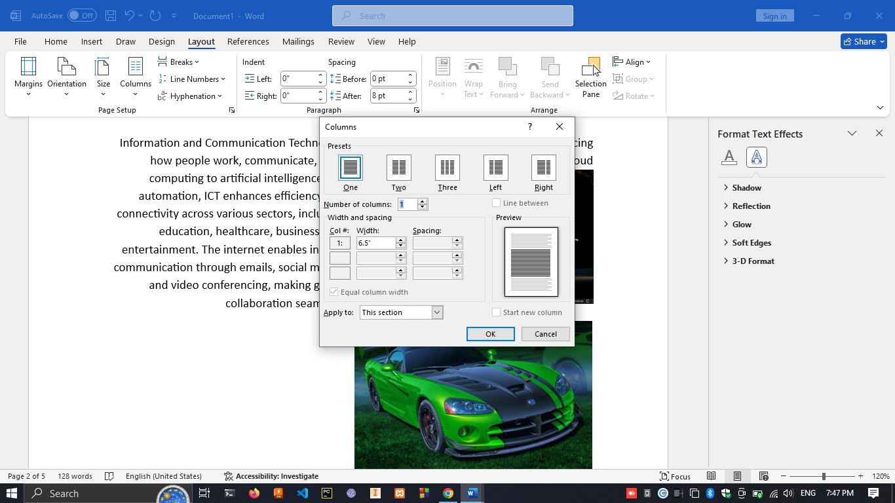

3. Under design -> click on watermark -> custom watermark -> select DRAFT under the text.

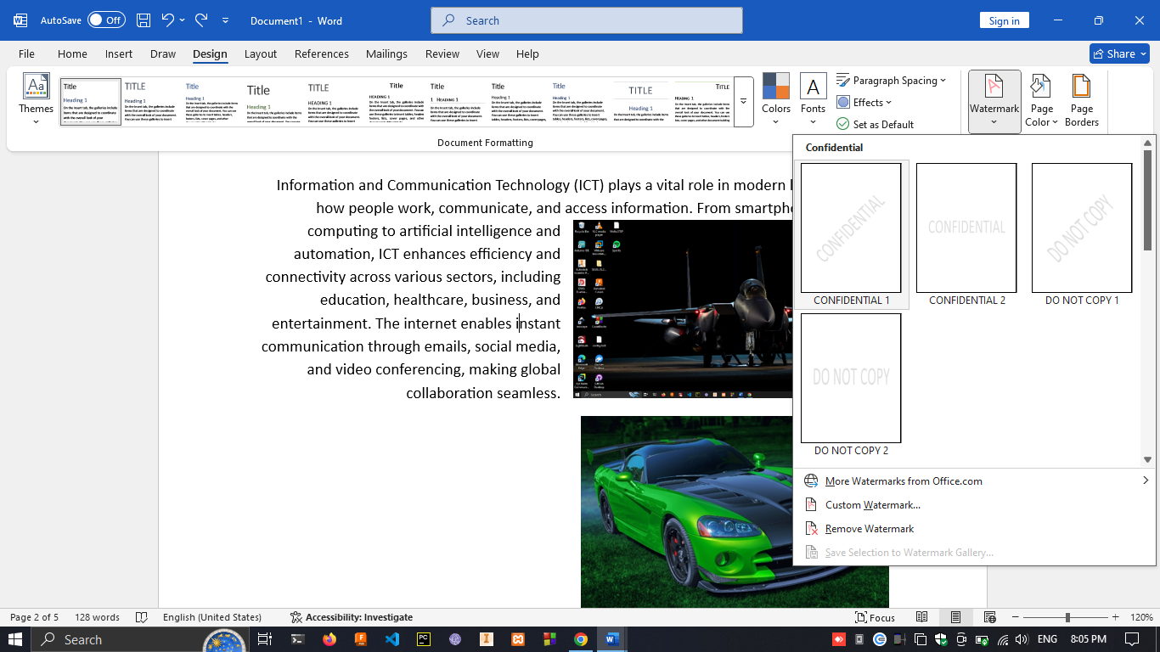 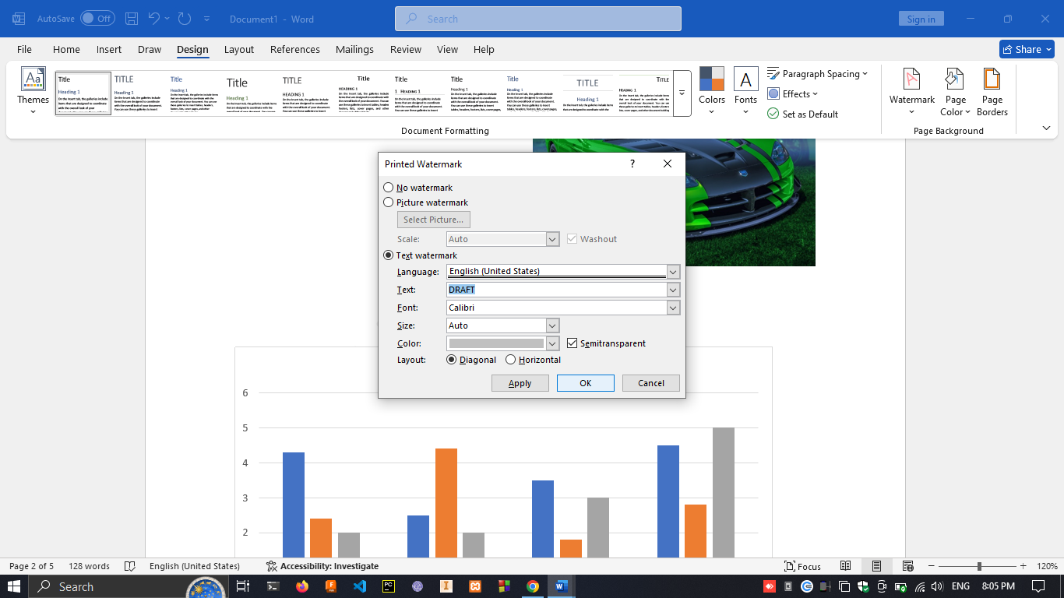

4. under file Click on Print -> type 2-4 in pages -> under print all pages click on “only print even pages”.

